**Topics**

* In-depth knowledge of at least one high-level programming language
* Understanding of core AWS services, uses, and basic AWS architecture best practices
* Proficiency in developing, deploying, and debugging cloud-based applications using AWS
* Ability to use the AWS service APIs, AWS CLI, and SDKs to write applications
* Ability to identify key features of AWS services
* Understanding of the AWS shared responsibility model
* Understanding of application lifecycle management
* Ability to use a CI/CD pipeline to deploy applications on AWS
* Ability to use or interact with AWS services
* Ability to apply a basic understanding of cloud-native applications to write code
* Ability to write code using AWS security best practices (e.g., not using secret and access keys in the code, instead using IAM roles)
* Ability to author, maintain, and debug code modules on AWS
* Proficiency writing code for serverless applications
* Understanding of the use of containers in the development process

<https://www.aws.training/Details/Curriculum?id=19185>

1. In Amazon S3, what do objects consist of?

 Image



 Video



 Object Data and MetaData



 Object Data



2. A user wants to launch an EC2 Instance for testing and tries to create a new EC2 Key pair also with name "test." But the test key pair is already present. What among the following options can happen?

 The user will get an exception



 It will override the existing the key pair



 Key pairs cannot be created using AWS SDK



 You can create multiple key-pair using the same name



3. Does Amazon DynamoDB remain available when you ask it to scale up or down by changing the provisioned throughput?

 TRUE



 FALSE



4. How do you grant an IAM user access to AWS Elastic Beanstalk?

 Role



 AWS SDK



 Policy



 Group



5. Which API do you need to use to disable or reenable an access key?

 UpdateKey



 ChangeKey



 UpdateAccessKey



 ModifyKey



6. Which command is used to view the Elastic Beanstalk events that are using AWS CLI?

 CD event



 eb events



 eb logs



 eb open



7. Company XYZ wants to implement a temporary credential for its users with limited access. How can they achieve this?

 Role



 Policy



 Access Key and Secret Access Key



 AWS STS



8. What type of MFA (Multi-Factor Authentication) is supported in AWS ?

 Email and security token based



 Push Notification and Email based



 Security Token and SMS based



 SMS and Push notification based



9. Amazon S3 charge is NOT based on which of the following options?

 storage



 Data Transfer in



 Ec2 Charge



 Data Transfer out



10. Which of the following APIs is NOT required to get started with Amazon SQS?

 SendMessage



 SaveMessage



 ReceiveMessage



 DeleteMessage



11. In AWS account, there are three workflows: workflow A, workflow B, and workflow C. A contains an order placed in Delhi, C contains an order placed in Mumbai. Can B access the data of A and C?

 Only A can be accessed



 Both of them can be accessed



 Only C can be accessed



 None of them can be accessed



12. What is the timeline for AWS Enterprise type support plan while dealing with a critical case ?

 <15 minutes



 <5 minutes



 <10 minutes



 <20 minutes



13. Can you use Alias records with your sub-domains?

 Yes



 No. None of them can be accessed



14. Which of the following are NOT valid protocols in SNS?

 HTTPS and SMS



 SMS and Email



 ELB and FTP



 All of the above.



15. What are the management tool services offered by AWS?

 CloudWatch and CloudFormation



 CloudWatch, CloudFormation, and Lambda



 CloudWatch, CloudFormation, and CloudTrail



 CloudFormation, CloudTrail, and Lambda



16. How many trails can you create per region using AWS Cloud Trail?

 5



 100



 10



 1



17. How long is metrics stored in Amazon Cloud Watch ?

 10 weeks



 1 week



 2 weeks



18. What is the default port of Microsoft SQL Server database in RDS?

 2510



 2340



 6510



 1433



19. The MAJOR advantage of a component-based development approach is the

 ability to manage an unrestricted variety of data types.



 provision for modeling complex relationships.



 capacity to meet the demands of a changing environment.



 support of multiple development environments.



20. What is the maximum size of a single S3 object?

 There is no limit



 3.5 terabytes



 4 terabytes



 5 terabytes



21. The MOST important reason for an IS auditor to obtain sufficient and appropriate audit evidence is to:

 comply with regulatory requirements.



 provide a basis for drawing reasonable conclusions.



 ensure complete audit coverage.



 perform the audit according to the defined scope.



22. How is the AWS EMR bill calculated?

 EC2 Instance charge



 EMR Charge



 S3, EBS Charge



 Combination of A, B, C



23. Which is NOT an AWS Database service?

 RDS



 DynamoDB



 DMS



 EMR



24. When a user gets this error, "Client.InvalidInstanceID.NotFound," what does it indicate?

 Specify the region



 Allow for eventual consistency



 Use the full ID of the resource



 Use none of the IDs of the resource



25. Which is NOT a part of AWS Trusted Advisor?

 Cost Optimization



 Quality



 Performance



 Security and fault tolerance



**1. What is used in S3 to enable client web applications that are loaded in one domain to interact with resources of the different domain? Choose the correct answer from the options below**

**A. CORS Configuration**

**B. Public Object Permissions**

**C. Public ACL Permissions**

**D. None of the above**

**Answer:** A

**Explanation:** Cross-origin resource sharing (CORS) configuration is a way to interact with resources in a different domain for the client web applications loaded in one domain. With CORS, you can build client-side web applications with Amazon S3 and also allow cross-origin to have access to the S3 resources selectively.

**2. Which of the descriptions below best describes what the following bucket policy does?**

**{    
   “Version”:”2012-10-17″,  
   “Id”:”Statement1”,   
   “Statement”:[    
      {    
         “Sid”:” Statement2″,  
         “Effect”:”Allow”,  
         “Principal”:”*”,  
         “Action”:[    
            “s3:GetObject”,  
            “s3:PutObject”  
         ],  
         “Resource”:”arn:aws:s3:::mybucket/*”,  
         “Condition”:{    
            “StringLike”:{    
               “aws:Referer”:[    
                  “http://www.example.com/*”,  
                  “http://www.demo.com/*”  
               ]  
            }  
         }  
      }  
   ]  
}**

**Choose the correct answer from the options below**

**A. It allows read or write actions on the bucket ‘mybucket’**

**B. It allows read access to the bucket ‘mybucket’ but only if it is accessed from example.com or demo.com**

**C. It allows unlimited access to the bucket ‘mybucket’**

**D. It allows read or write access to the bucket ‘mybucket’ but only if it is accessed from example.com or demo.com**

**Answer:** D

**Explanation:**The PutObject allows one to put objects in an S3 bucket.

**3. Is the default visibility timeout for an SQS queue 1 minute?**

**A. True**

**B. False**

**Answer:** B

**Explanation:** The visibility timeout of each queue is 30 seconds by default. It is possible to change this setting for all the queues. Typically, the visibility timeout is set to the average time it takes in processing and deleting a message from the queue. While receiving messages, special visibility timeout can be set for the returned messages without making any change in the overall timeout of the queue

**4. When a failure occurs during stack creation in Cloudformation, does a rollback occur?**

**A. True**

**B. False**

**Answer:** A

**Explanation:** By default, the “automatic rollback on error” feature is enabled. It causes AWS CloudFormation to be created successfully for a stack until the point of error is deleted. This is useful when the default limit for Elastic IP addresses is exceeded accidentally, or you can’t access an EC2 AMI you want to run.

This feature makes you depend on the fact that stacks may either be fully created or not at all. It simplifies the layered solutions system administration built on the top of the AWS CloudFormation.

**5. An administrator is getting an error while trying to create a new bucket in S3? You feel that bucket limit has been crossed. What is the bucket limit per account in AWS? Choose the correct answer from the options below**

**A. 100**

**B. 50**

**C. 1000**

**D. 150**

**Answer:** A

**Explanation:** This is clearly mentioned in the AWS documentation.

**6. Which of the below functions is used in Cloudformation to retrieve an object from a set of objects? Choose an answer from the options below**

**A. Fn::GetAtt**

**B. Fn::Combine**

**C. Fn::Join**

**D. Fn::Select**

**Answer**: D

**Explanation:** This is clearly given in the AWS documentation

**7. Which of the below functions is used in Cloudformation to append a set of values into a single value? Choose an answer from the options below**

**A. Fn::GetAtt**

**B. Fn::Combine**

**C. Fn::Join**

**D. Fn::Select**

**Answer:** C

**Explanation:** This is clearly given in the AWS documentation

**8. What is the max size of an item that corresponds to a single write capacity unit? (While creating an index or table in Amazon DynamoDB, it is required to specify the capacity requirements for the read and write activity)?.**

**Choose an answer from the options below.**

**A. 1 KB**

**B. 4 KB**

**C. 2 KB**

**D. 8 KB**

**Answer:** A

**Explanation:** This is clearly given in the AWS documentation

**9. What can be used in DynamoDB as a part of the Query API call for the filtration of results based on the primary keys’ values? Choose an answer from the options below**

**A. Expressions**

**B. Conditions**

**C. Query API**

**D. Scan API**

**Answer:** A

**Explanation:** This is clearly provided in the AWS documentation

**10. Can a global secondary index create at the same time as the table creation?**

**A. True**

**B. False**

**Answer:** A

**Explanation:** This is clearly given in the AWS documentation

**11. A Global Secondary Index can have a different partition key and sort key from those of its base table.**

**A. True**

**B. False**

**Answer:** A

**Explanation:** GSI can also use the same partition key as the base table. Even in the AWS documentation, they say that GSI can use a different partition key and sort key. However, anywhere in the document, they are not saying that it has to be different.

AWS Console Test:

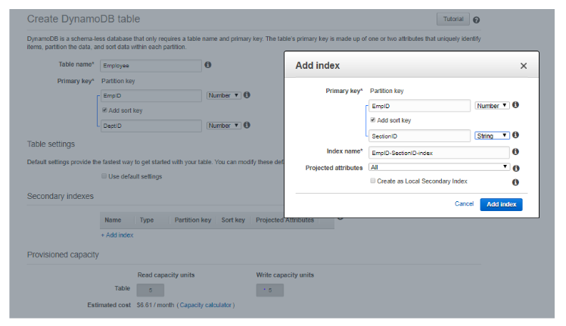“EmpID” is my base table partition key, which I’m using in both GSI and LSI.

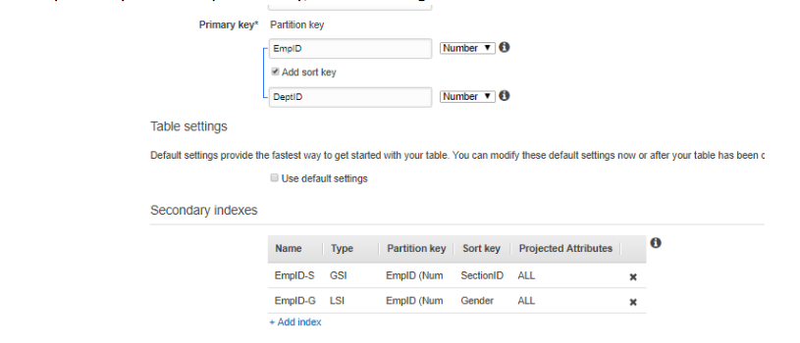  
The table is created successfully.

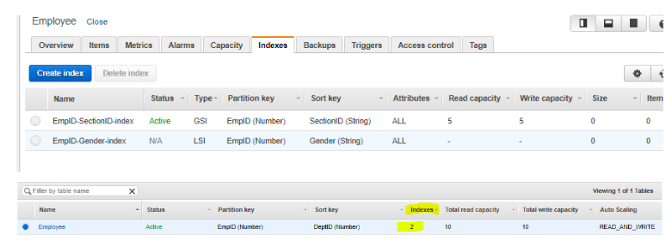

So now we have seen that we can create GSI with the same partition key as the Base table.

Global secondary index — Global secondary index is an index where both the partition key and sort key can be different from that of the base table. The global secondary index is named as global because here the queries can span all the data in the base table over all the partitions.

Local secondary index — Local secondary index is an index where the partition key is the same as that of the base table, while sort key is different. The local secondary index is named as local as all the partitions here are scoped to a base table partition having the same partition key value.

**12. What in AWS can be used to restrict access to SWF?**

**A. ACL**

**B. SWF Roles**

**C. IAM**

**D. None of the above**

**Answer:** C

**Explanation:** This is clearly mentioned in the AWS documentation

**13. An IT admin has enabled long polling in their SQS queue. What must be done for long polling to be enabled in SQS? Choose the correct answer from the options below**

A. Create a dead letter queue

B. Set the message size to 256KB

C. Set the ReceiveMessageWaitTimeSeconds property of the queue to 0 seconds

D. Set the ReceiveMessageWaitTimeSeconds property of the queue to 20 seconds

**Answer:** D

**Explanation:** Amazon SQS long polling is a method of retrieval of messages from SQS queues. It returns a response only when a message arrives in the message queue instead of short polling where the response returns immediately even when the message is empty.

As the messages are available, the retrieval of messages from Amazon SQS becomes inexpensive due to long polling. It may also reduce the cost of using SQS as it can reduce the empty receipts.

**14. As per the IAM decision logic, what is the first step of access permissions for any resource in AWS? Choose the correct answer from the options below**

**A. A default deny**

**B. An explicit deny**

**C. An allow**

**D. An explicit allow**

**Answer:** A

The below diagram shows the evaluation logic of IAM policies. And as per the evaluation logic, it is clear that the above scenario leads to a default deny.

**15. Which API call is used to Bundle an Amazon instance store-backed Windows instance? Choose the correct answer from the options below**

A. AllocateInstance

B. CreateImage

C. BundleInstance

D. ami-register-image

**Answer:** C

**Explanation:** This is given in the AWS documentation